**CHAPTER I**

**THE PROBLEM AND ITS BACKGROUND**

**Introduction**

Nowadays, in digital era, it has brought enormous progress throughout the human world. Everything are in digital form where it cannot be denied that it is much preferable because it is easier, convenient, and can be stored anywhere. As the technology advances, people are also expected to embrace and keep up with the changes that is happening. All fields now are in capable of keeping up with the advancement of technology.

In construction, they are the one who are responsible for building and developing infrastructure, which will be needing of the people. According to the article of Go Construct (2022) entitled What is Construction, it states that construction is critical in industry because it creates buildings and spaces that connect communities, provide jobs, and improve society. However, in the field of construction it is much more in paper and pen works since there are less systems available that would help the field. The field of construction are still in the process of embracing the digital era in which the systems are all digitalized because as of today they are still storing their data through hardcopy. There are a lot of data that needs to be stored in terms of the field of construction, from the employees, materials, tools, equipment, and supplies. But it would be harder if these data’s will be stored in traditional way. Therefore it is much easier to store and organize data through digital system.

**Background of the study**

In this study, construction project management system, the main goal is to enhance the procedure for keeping track of construction projects' status updates. This system will be a tool that can be used to track the progress of the company in terms of employee management, tool management, equipment management, and supplies management. As what is mentioned in the article of CMAA (2022), construction management is a professional service that provides successful management of a project's time, cost, quality, safety, scope, and function to the project's owner(s). This system will be helpful for the company and other members who will be in the field of construction.

Moreover, this solution will enhance data management and storing. The system will offer a schedule of events that will aid in enhancing user interaction and communication. Data updates and system management are only possible for the administrator. Through this system it will help the field of construction since the system that will be created will be beneficial for them.

**Setting of the study**

This study will take place in Seas 226 Construction Supplies Trading at Malaruhatan Lian Batangas, under the guidance of Engr. Froilan S. Villegas. In this company, it can be observed that there is a need in storing and organizing of data.

In line with this, the researchers will conduct the study in the said company since this will be helpful for easy access of data since it is stored in one place and this will help them to easy manage their data.

**Statement of the Problem**

The researchers’ aims to help the company to have easier access and management of data as this study will provide a system that will help them to store and organize data in easy way. This will help them to eliminate the traditional way of the company which is storing and managing data through hardcopy which uses paper and pen.

Furthermore, the data that will be stored through hardcopy are more time consuming and requires a lot effort to do. So, this study will be advantageous for the company and the client as well. From the problem of storing and managing data through traditional way to digital system, it will make their work easier that before.

**Significance of the study**

**The Company.** The result of the study and the system that will be developed will be beneficial for the company since it will help them to manage, store, and access data in easier way.

**The Client.** The result of the study and the system that will be developed will advantageous for the client because this will help them to monitor the performance of the company.

**The Future Researchers.** The result of the study and the system that will be developed will help them as it will provide them basis for their study that is related with the current study.

**Scope and Limitation**

This study will be focusing on the company of Seas 226 Construction Supplies Trading at Malaruhatan Lian, Batangas. This research aims to help the company to manage, store, and access their data through digital system that will be easy work for them.

**Scope:**

1. The system includes project planning and scheduling
2. Staff and employee monitoring including time arrival and departure on the site.
3. Project information modelling that have a document management feature to organize reports and information.
4. Allows user to manage the inventory of construction supply and all equipment.
5. Provides an interface that can manage a document such as contacts, and other paperwork.
6. Storing of employees contact information. It can be use in the communication feature for email, text messages, and phone calls.
7. It can generate reports
8. Provides a platform to create job scheduling and task assigning.
9. It can manage the payroll of the employees.

**Limitation:**

1. This system has no billing transaction, due to the fact that the system focus only in the Construction Project Management.
2. This system can’t sell product or supply.
3. Can’t set up the deduction in generating the payroll.

**CHAPTER II**

**PROGRAMMING PROCEDURE**

**Context Diagram**

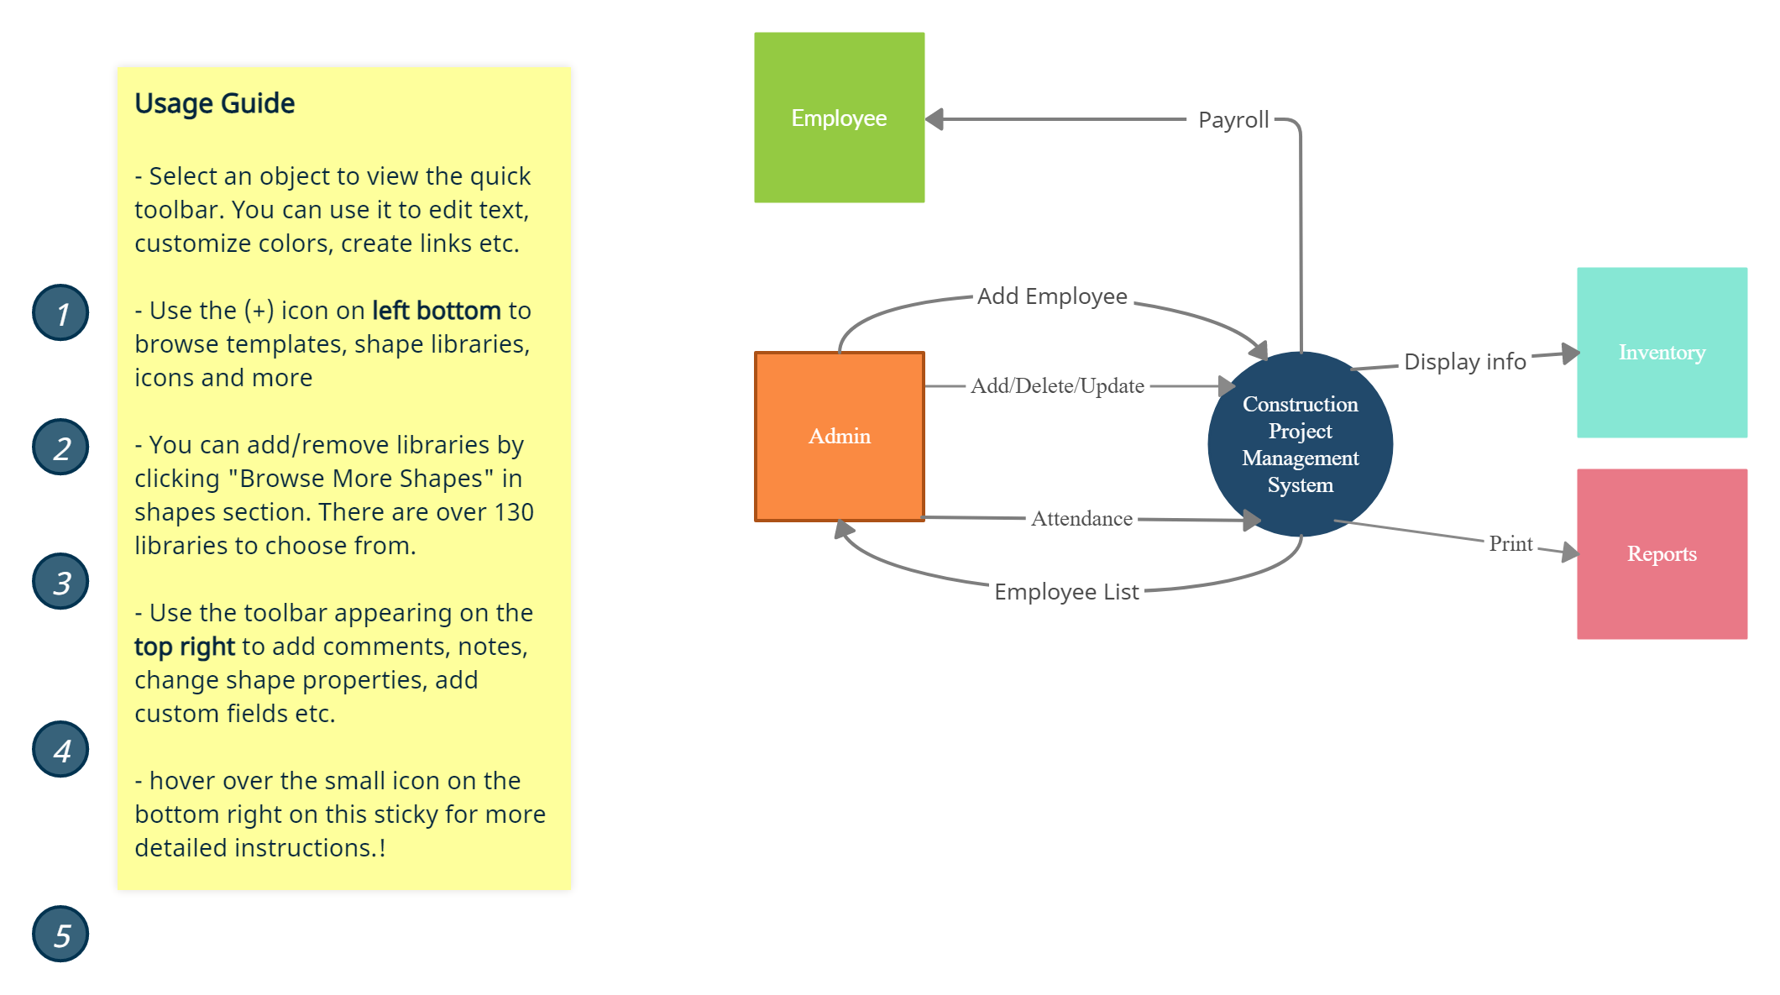

**Data Flow Diagram**

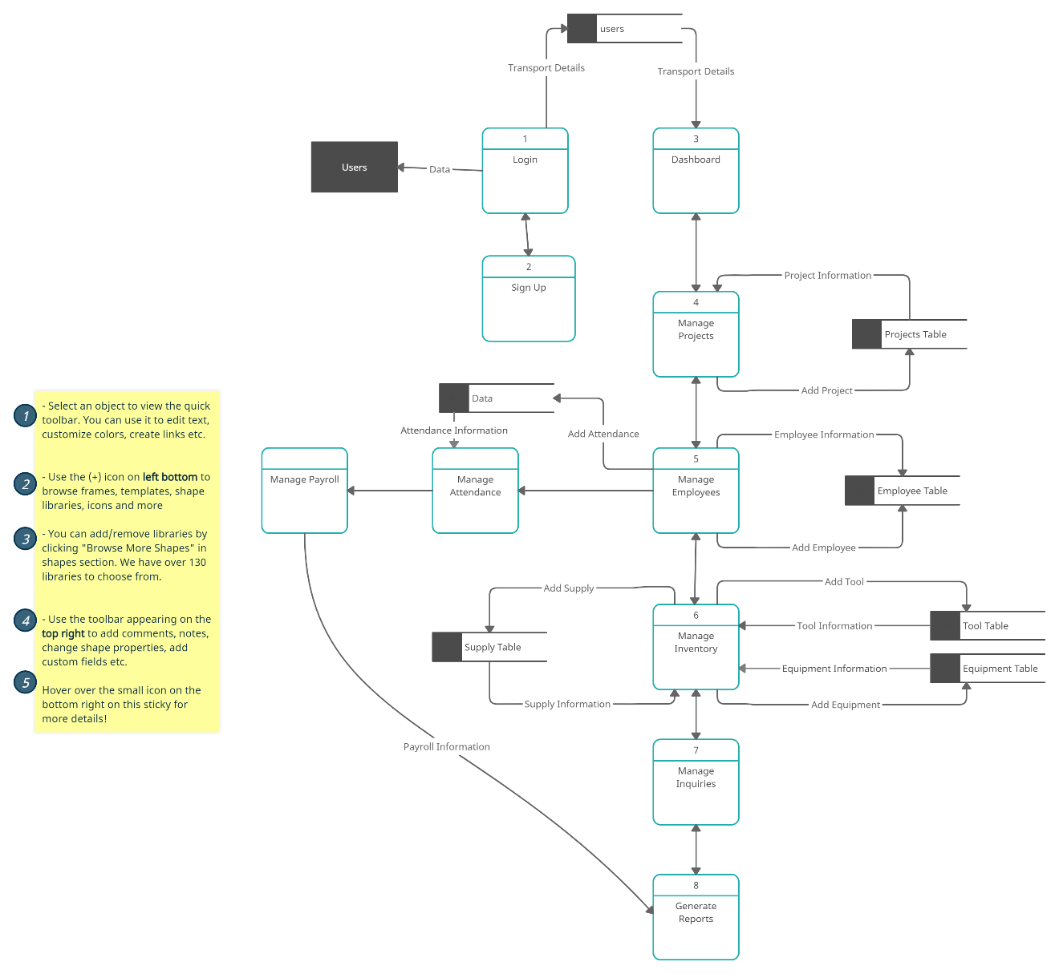

**ERD (Entity Relationship Diagram)**

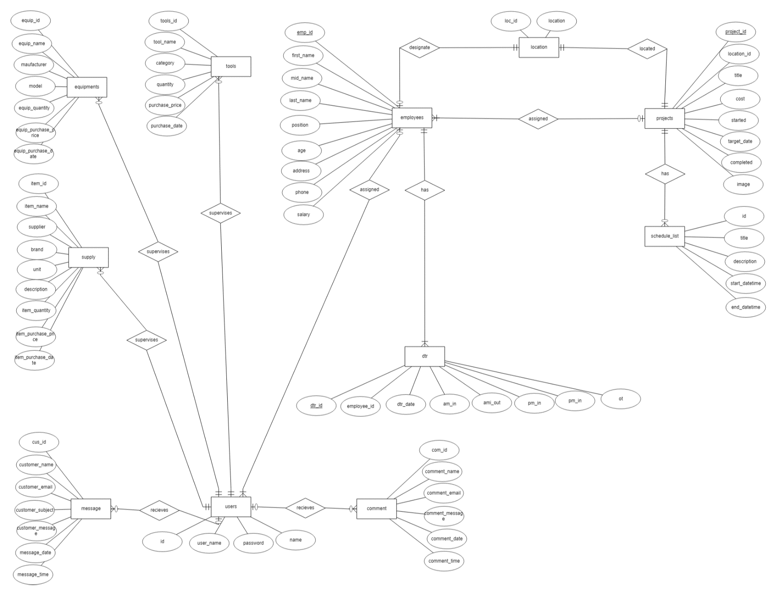

**CHAPTER III**

**RESULT AND DISCUSSION**

This chapter provides the information on the specification of the software and hardware utilize in producing a system

**Software Requirements**

This provides information about the software requirements and specifications that used to build and develop the system.

**Table 1.Software Requirements and Specifications**

|  |  |
| --- | --- |
| **Software** | **Specifications** |
| **OS** | **64-Bit OS** |
| **Programming Tools** | **Php,Html** |
| **IDE** | **Sublime, Visual Studio** |
| **Data Base Management System** | **Xampp** |

**Table 1. Shows the list of software requirements that been used to develop our system.**

The 64-bit operating systems will be used by programmers to run the system. Moreover, 64-bit operating system are more capable and can deliver better and faster graphics. The Sublime here is used to makes coding more easily and more fun. Also the Php here is used to the content through scripts and the Html here is used for general structures. The Xampp here is used to test and verify the working of the system. Also to manage data that are stored in the system.

**Hardware Requirements**

This provides information on hardware that used to develop the system and to this hardware that will stated below will provide adequate performance for the services or to develop the system.

**Table 2. Hardware Requirements and Specifications**

|  |  |
| --- | --- |
| **Hardware** | **Specifications** |
| **Laptop** | **Windows 10,11** |
| **Processor** | **11th Gen Intel(R) Core(TM) i5-1135G7**  **2.40GHz-2.42GHz** |
| **RAM** | **8GB** |
| **ROM** | **500GB** |

**Table 2. Shows the list of hardware requirements that researchers use to build and develop the system.** The hardware requirements are Windows 11 Laptop,11th Gen Intel(R) Core(TM) i5-1135G7 2.40GHz-2.42GHz processor, 8GB RAM to enhance the development of the project

**CHAPTER IV**

**CONCLUSION AND RECOMMENDATION**

**Conclusion**

This study was conducted to help a construction company managing and checking the progress of the projects and what tasks will be accomplished in the stated schedule. It can also be the way to know who will be involved in the working site and to monitor the materials. Having changes in construction projects are very common but by the used of the system it will enhance company by keeping track of the construction projects. It is simple to use and connects workplace and site for real-time visibility. As a result, this will benefit company as the system provides service such as storing and managing the data.

**Recommendations**

The company must know how to execute the system in order for it to work properly. There must be an assigned department that will be assigned in handling the system. This will be done if the company provides time to know how to deal with the system.

Based on the observation of the researchers, it is difficult to switch immediately from what they have been doing traditionally, that is why the researchers recommend to explore new planning and execution strategies to maximize outcomes of the project all over the project life cycle. It is also recommended to generate the deduction in payroll.

**CURRICULUM VITAE**



**Kenneth B. Alvarez**

Brgy. Malaruhatan, Lian, Batangas

[20-78331@g.batstate-u.edu.ph](mailto:20-78331@g.batstate-u.edu.ph)

0907-910-6448

**Personal Information**

Home Address: Brgy. Malaruhatan, Lian Batangas

Date of Birth: July 11, 2000

Place of Birth: Brgy. Malaruhatan, Lian Batangas

Civil Status: Single

Religion: Roman Catholic

Parents: Marivic M. Balbar

Ariel M. Alvarez

______________________________________________________________________

**Educational Background**

College Batangas State University ARASOF Nasugbu

2020-present Brgy. Bucana, Nasugbu, Batangas

Senior High School Lian Senior High School

2018-2020 Brgy. Malaruhatan, Lian Batangas

Secondary Lian National High School

2014-2018 Brgy. Malaruhatan, Lian Batangas

Primary Malaruhatan Elementary School

2007-2014 Brgy. Malaruhatan, Lian Batangas



**John Paulo A. Bascuguin**

Brgy. Kapito, Lian, Batangas

[20-71291@g.batstate-u.edu.ph](mailto:20-71291@g.batstate-u.edu.ph)

0939-542-4305

**Personal Information**

Home Address: Brgy. Kapito, Lian Batangas

Date of Birth: March 27, 1999

Place of Birth: Nasugbu, Batangas

Civil Status: Single

Religion: Roman Catholic

Parents: Mila A. Bascuguin

Fernando D. Bascuguin

_____________________________________________________________________

**Educational Background**

College Batangas State University ARASOF Nasugbu

2020-present Brgy. Bucana, Nasugbu, Batangas

Senior High School Lian Senior High School

2018-2020 Brgy. Malaruhatan, Lian Batangas

Secondary Lian National High School

2011-2015 Brgy. Malaruhatan, Lian, Batangas

Primary Lian Central School

2004-2011 Brgy. Uno, Lian, Batangas



**Ruzell Anne A. Del Carmel**

Brgy. Lagnas, Balayan Batangas

[20-77106@g.batstate-u.edu.ph](mailto:20-77106@g.batstate-u.edu.ph)

0963-354-7366

**Personal Information**

Home Address: Brgy. Lagnas, Balayan Batangas

Date of Birth: April 07, 2002

Place of Birth: Silang, Cavite

Civil Status: Single

Religion: Roman Catholic

Parents: Ferdinand R. Del Carmen

Mariccel A. Del Carmen

_____________________________________________________________________

**Educational Background**

College Batangas State University ARASOF Nasugbu

2020-present Brgy. Bucana, Nasugbu, Batangas

Senior High School Balayan Senior High School

2018-2020 Brgy. Caloocan Balayan, Batangas

Secondary Balayan National High school

2014-2018 Brgy.10 Balayan, Batangas

Primary Balayan West Central School

2008-2014 Brgy. 12 Balayan, Batangas



**Jordan P. Jonson**

Brgy. Prenza, Lian, Batangas

[20-71233@g.batstate-u.edu.ph](mailto:20-71233@g.batstate-u.edu.ph)

0927-293-0889

**Personal Information**

Home Address: Brgy. Prenza, Lian Batangas

Date of Birth: January 13, 2002

Place of Birth: Nasugbu, Batangas

Civil Status: Single

Religion: Roman Catholic

Parents: Ningning P. Jonson

Romeo A. Jonson

_____________________________________________________________________

**Educational Background**

College Batangas State University ARASOF Nasugbu

2020-present Brgy. Bucana, Nasugbu, Batangas

Senior High School Lian Senior High School

2018-2020 Brgy. Malaruhatan, Lian Batangas

Secondary Lian National High School

2014-2018 Brgy. Malaruhatan, Lian, Batangas

Primary Lumaniag, Elementary School

2008-2014 Brgy. Lumaniag, Lian, Batangas

**PICTURES WITH PARTNERS (during interviews)**

